# Milestone 2 submission

**Team name**

FlatDyn Games

**Proposed Level of Achievement:**

Apollo 11

**Motivation**

Nowadays, the game industry is developing rapidly. Its influence cannot be ignored. Video games are no longer just for entertainment, and the technology in this field can even be applied to other fields such as movies, medical care, driverless driving, and urban planning.

As one of the traditional game concepts, 2D platform jumping game has countless masterpieces, such as "Ori and the will of the wisps" and "Dead Cells". We have decided to develop a game of this type as the first step in exploring the game development techniques.

**Scope**

Edge of Adventure is a single-player 2D platform jumping game set in a fictional world.

Players will experience interesting combat systems and diverse enemy modes of action.

Players can gain experience points and collect various props during the adventure.

The complete storyline and beginner guide will navigate players to enjoy the whole world outlook and learn how to control the character.

**User stories**

1. Smooth program operation.

2. Control the character to complete movements, attacks, and other commands.

3. Switch between different screens such as the main menu and settings, and freely select levels.

4. Experience the full game visuals and sound effects.

5. Have fun and enjoy the game.

**Core features(proposed)**

Edge of Adventure will be a 2D platform jumping game which focus on the combat system. We will make the animations look smooth, with natural transitions between each action. The character controlled by players will have various of skills. Players can combine different skills to form combos. Additionally, the character will have some defense measures to deal with the enemy, such as block or evasion. It depends on players to destroy the enemy with stormy attacks or expose their weaknesses with targeted defense. A new map is undergoing creation.

**Features Developed**

By the end of milestone2, the main character in edge of adventure can throw attacks, perform hurt or dead animation when receiving damages. On top of that, our main character can dash which avoids all the attacks and can crouch to jump higher. In the perspective of quality gaming, a camera is designed to follow the player and shake when player gets hurt giving more interactive feedback to the game. Also, a visible health bar to remind player’s health to enhance the experience.

Player will encounter challenges as there are now two new enemies – spear and axe. The Spear will start running around with its weapon pointing forward and the Axe will hunt down player and swing its axe when player is within its attack range.

**Tech stacks(current)**

Unity

- The game engine that our game runs on

C#

- The language used to code in Unity

Adobe Animate

- The sprite maker

**Design and plan**

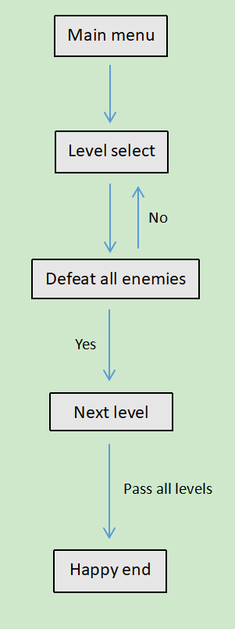Game flow diagram

Prospective design in next milestone

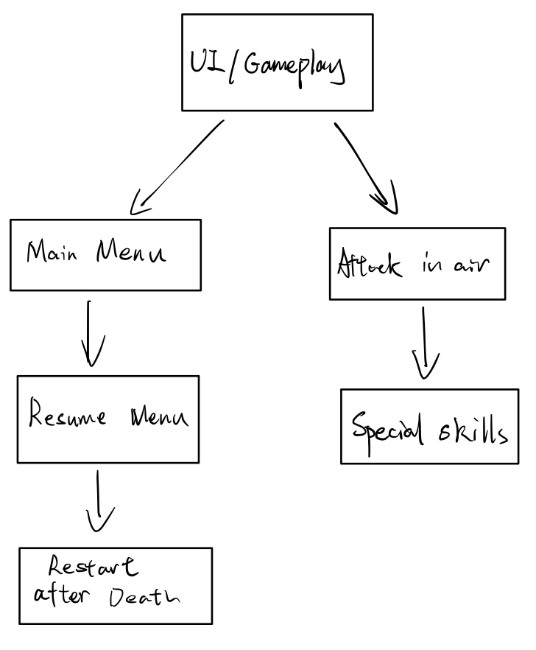

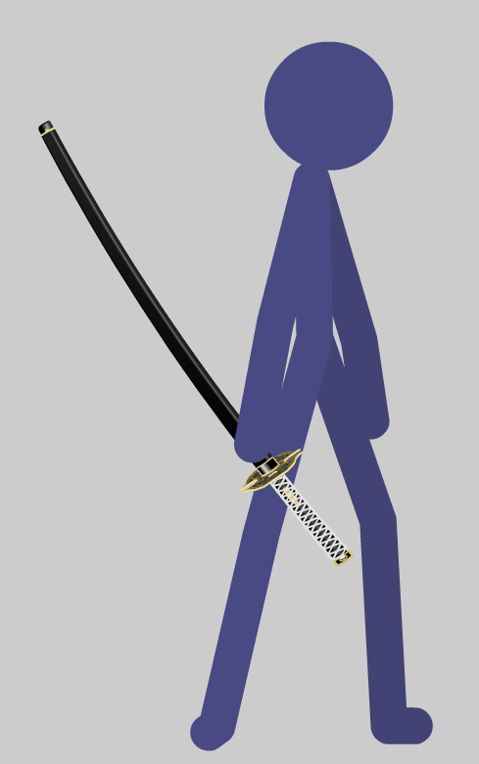Hero

Enemy Axe

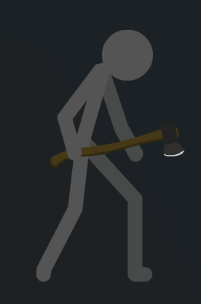

Enemy Spear

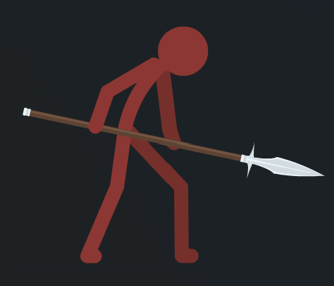

Project Log

Project Poster

Project Video Demonstration